INTRO TO WEB TECH REVISION PRACTICAl

1. With the Knowledge of HTML elements and attributes, you must create a web page similar to the one below. Use this text:

Richfield education offers all students who choose to study any one of our IT courses the opportunity to receive more than just a degree or qualification through our badges and certification from courses facilitated by IBM, AWS, CISCO, ORACLE, and CIMA -which are some of the world's leading organization courses from these industry-leading organizations are integrated into the Richfield curriculum, which helps them tap into their creative thinking and expand on what is being taught to them in more innovative ways. These courses also foster a mindset of independence and solutions-driven thinking through research and applying real-life scenarios, which provides students with an in-depth understanding of the real world of IT.

1. 
2. Write HTML code to design the following web page. You may use the snipping tool to extract the Richfield logo.

1. Create an html code that generates a table that displays as the image below. Replace your name and the marks.

1. Create an html Lecturer evaluation form that displays as the image below, check the options for Knowledge, Communication and Organization

1. Create an html CV portfolio for an IT Lecturer. Creativity and good organization of your content will score more marks. Make use of the text provided and include the following **(30 Marks)**

* A heading with your Web technology Lecturer name (h1)
* An image of the Lecturer (lecturername.png)
* A short introductory video of the Lecturer (lecturername.mpge), include the controls.
* A short paragraph of the Lecturer qualities and area of expertise
* A heading for the Qualifications (h2)
* An unordered list of the qualifications
* A heading for the modules (h3)
* An ordered list of the modules he/she Lectures
* A link to their linkedin profile (<https://za.linkedin.com/>) that displays on a separate page
* Include a header and a footer  with email address and contact details

Paragraph

I am an experienced IT Lecturer specializing in web technology. With a passion for teaching and a strong background in the field, I strive to provide comprehensive and engaging learning experiences for my students.

Qualifications

Bachelor's degree in Computer Science

Master's degree in Information Technology

Teaching Certification in Higher Education

Modules

Web Development Fundamentals

HTML and CSS

JavaScript and jQuery

Responsive Web Design

Web Application Development

Database Design and Implementation

**Contact details**

Email: lecturer@richfield.ac.za

Contact: +1234567890

1. As a Junior Web developer, your assignment is to arrange student information in a table format similar to the image provided below. Additionally, you need to include four more records to make a total of ten records in the table. Once completed, save this table as studentRecords.html.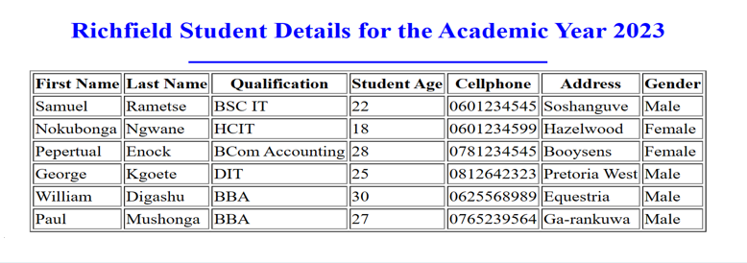

8. You, as a web developer, have been tasked with creating a sign-up form for a forthcoming IT event, specifically designed for Richfield students. The form should have the following sections,

1.Personal details

2.Contact details

3.Event details

The required format for the form is as follows.

1. Write HTML code that will produce the following web page:

9.Assume that you have been tasked with designing a form for a church membership online registration. Write html code to design the form as shown below. The book club image(logo) is named Logo.png

